**SQL Library Project**

CS 4347.002

Team F

Team member:

Sailesh Andra, Caleb Ernst, Yong hyun Lee, David Yang, Matthew Basinger

Github Repository:

https://github.com/4347groupF/dbproject

**I. Project Description**

For this project, we selected Python Django for backend development and HTML, CSS, and JavaScript for the frontend. Our architectural choices were informed by the need to integrate with Django’s Model-Template-View framework. This integration required us to adopt a non-traditional approach, specifically segregating data access and user interface components into distinct files. To enhance the user experience, we focused on creating an intuitive and user-friendly graphical interface. This was achieved by utilizing CSS and JavaScript to complement our HTML structure, starting with a clear initial login/sign-up/librarian menu that leads to the book search feature. Additionally, we have incorporated a consistent menu tab accessible across all pages for effortless navigation of our website. One of the most significant strengths of our application is its independence from any specific platform, operating system, or framework requirements; a current version of Python is sufficient to run the program.

**II. Architecture**

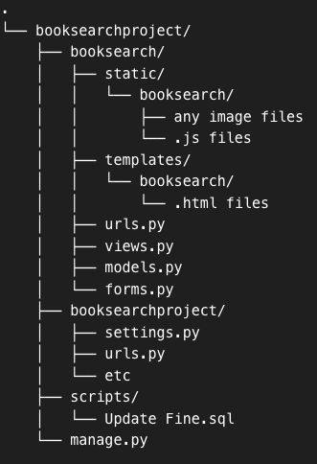

**III. Roles**

|  |  |  |
| --- | --- | --- |
| **Name** | **Responsibility** | **Sub-group** |
| Sailesh Andra | MENU bar, Profile, CheckOut, SearchResults design | Front-end |
| Caleb Ernst | Librarian features, SignIn, SignUp, index page, and Failure page design | Front-end |
| Yong hyun Lee | Primary architect and team lead / Login, Profile, Check-In & Out logic | Back-end |
| David Yang | Database setup and schema creation, Book loans, SignUp, Fines page | Back-end |
| Matthew Basinger | Primary documenting / Index and Book search logic | Back-end |